Examples of Screen-Print Related Parameters
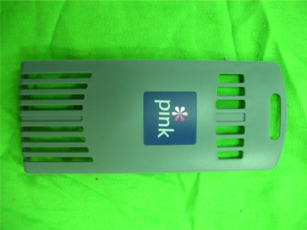
- Screen Mesh: 300 mesh
- Screen Material: Nylon
Because the printed object is curved, the elastic screen is needed to prevent squeegee from deformation
- Printed Object Material: ABS
- Ink: Find Cause Ink (ABS Special Ink)
- Solvent: Find Cause Solvent (Slow Evaporating)
- The Amount of Solvent Added: 6%
- Squeegee Used: 70 Degree Bevel Squeege
- Height between Screen Plate and Printed Object: 1.5mm
- Scraping Direction: Left to Right
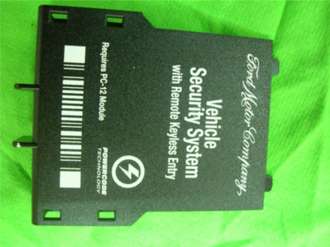
- Screen Mesh: 300 mesh
- Screen Material: Tetoron
We use harder screen cloth because the squeege will leave the screen instantly after scarping. This can reduce ink diffusion.
- Printed Object Material: ABS
- Ink: Find Cause Ink (ABS Special Ink)
- Solvent: Find Cause Solvent (Slow Evaporating)
- The Amount of Solvent Added: 6%
- Squeegee Used: 80 Degree Rectangular Squeegee
There is etching pattern on the surface of the printed object. Threrefore, we use harder rectangular squeegee so that the it is sealed with printed object when scarping.
- Height between Screen Plate and Printed Object: 2.5mm
I Scraping Direction: Left to Right
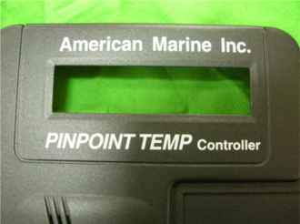
- Screen Mesh: 300 mesh
- Screen Material: Tetoron
We use harder screen cloth because the squeege will leave the screen instantly after scarping. This can reduce ink diffusion.
- Printed Object Material: ABS
- Ink: Find Cause Ink (ABS Special Ink)
- Find Cause Solvent (Slow Evaporating)
- The Amount of Solvent Added: 8%
- Squeegee Used: 70 Degree Rectangula Squeege
The surface of the printed object is flat and smooth. Therefore, we use regular rectangular squeegee so that it will not damage the screen when scarping.
- Height between Screen Plate and Printed Object: 2mm
- Scraping Direction: Left to Right

