How to Select Suitable Rubber Pads?
Shapes & Sizes of the Pads
- Normally, we select the pads basing on the sizes of the printed pattern.
- If there are many fine lines, we use sharper and harder pads.
- Use bigger/softer/flater pad for bigger printed pattern.
- If there is combination of the pattern, use combinative pads.
- When pressing the pad to a certain level, the pressing angle is not good for exhaustion. Therefore, do not choose too small pads when basing on printed size.
- When using harder pad, the pressing speed must exceed ink-floating speed. Otherwise, the underflow-ink might occur.
- When the ink contains too many bubbles, a harder pad can sometimes discharge the air out of the ink.
- When the printed area is curved, the deformation occurs when you press the pad too fast.

Silicone Colors

- Generally, we use different colors to distinguish pads’materials.
- Find Cause pads – Different colors for different pad characters.
Red: High Hardness; Good Ink-Absorption; Suitable for bad-exaust and etching patterns.
White: Softer Pads; High-Ductility; Used to cover irregular pattern and not easy to break.
Blue: Good Anti-Solvent Resistance; Used for massive printing; Enhance the life of the pads.

Hardness of the Pads

- Some silcone are soft and suitable fpr soft pads. However, some silcone are only suitable for hard pads If making it into soft pads, it will reduce the life of the pads.
- Normally, the sharper/harder the pads are, the better exhaustion they are. Therefore, we use sharper/harder pads for thinner lines and patterns
- Hard pads are with better exhaustion but it is also easier to cause underflow-ink.
- For bigger area printing, use softer pads to avoid uneven shades.
- The harder the pads are, the greater that the pads can hold when printing.

Ink Absorption for Pads

- Better anti-solvent pads, the ink absorption is worse.
- Old pads’ ink absorption is better than new pads.
- Printing in advance to test the concentrated dilutions of the ink. If the evaporation is ok but the pad can still not absorbing the inks, use the cloth to clean up the pad.
- Clean the pad surface can enhance the ink absorption; however, it can reduce its deinking as well.
- Try not to pause too long when sticking the ink. Do not stop the machine and expose the content on the steel plate. These may cause the incompleted ink-sticking.

Deinking of the Pads

- The longer the pads are used, the deinking is worse because of the solvent corrosion to the pads and friction between pads and printed objects.
- The faster the ink evaporating speed, the better the deinking is.
- When pressing the pad before touching the object, you can stop for 0.3-1.5 second (to make the ink a bit more dry) and then press down. This is helpful for deinking. It especially works better using the dryer (Using dryer in winter helps the ink evaporation)
- The deinking effect is the best when the pad ink is at semi-dry state. The deinking process can be done successfully more than 10000 times per day.

Life of the Pad
- Normally, a pad can be used 10K – 50K times.
- Factors affecting the pad lives:
A: Squeezing Variant
B: Solvent corrosion
C: Oxidation

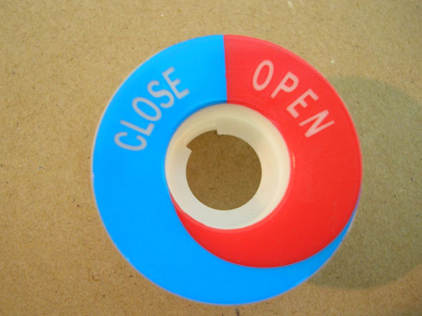
This product is suitable for softer/flater pad.
- FC-06 Pad; Red Silcone; Hardness: 20%
- Ink: RUCO180 +30% Clear Coat
- Solvent: Fine Cause Extra Fast Evaporating Solvent
- Steel Plate Depth: 33u-36u
- Machine: FC-252 2-Color Pad-Printer
- Printed Object Material: Nylon
- Use dryer to assist deinking
- Stop before sticking ink: 0 second
Stop after sticking ink: 0.3 second
Stop before printing: 0.7 second
Stop after printing: 0.5 second
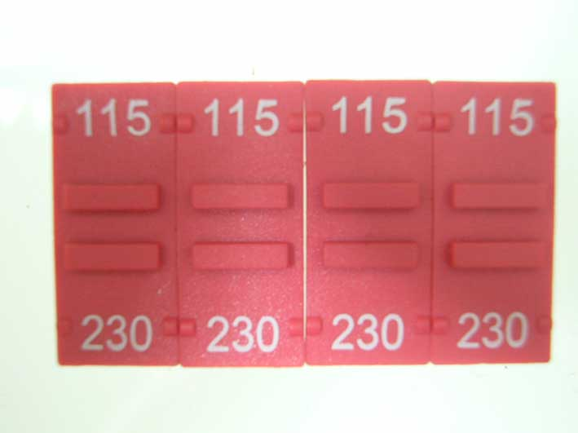
This product is suitable for sharper/harder pad.
- FC-120 Pad; Red Silcone; Hardness: 0%
- Ink: SEIKO-VIC Series
- Solvent: Fine Cause Extra Fast Evaporating Solvent
- Steel Plate Depth: 20u-22u
- Machine: FC-125 Single Color Pad-Printer + Auto Sliding Rail
- Printed Object Material: Nylon
- Use dryer to assist deinking
- Stop before sticking ink: 0 second
Stop after sticking ink: 0.3 second
Stop before printing: 0.3 second
Stop after printing: 0.3 second

