FINECAUSE ENT. CO., LTD.

Steel Plate Inspection Standards

- The steel plates manufactured by most of the “Plate Manufacturers”are with the problem of the color difference when actual production even though that the etched depth reaches the standard.
- Therefore, Finecause come up with the solution. Besides the basic depth inspection, we build the model for future produced steel plates and establish the series numbers.
- This is what we call “Double Inspection”: 1. Depth 2. Design Size (Round Dot Size)
- Accuracy of the depth represents the thickness of the color whereas design size (dot size) affects our judgement of the color deeply.
- In conclusion, under the situation that the color looks the same, the visual effect may cause the color shades because of the design size (dot size).

Example: 2.5D Mesurement Design Match

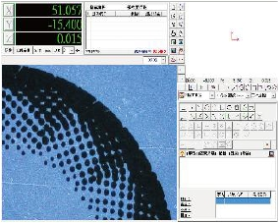

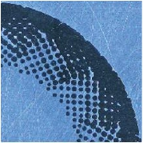

A . Design – Film A. Design – 6/6 Produced Plate-1

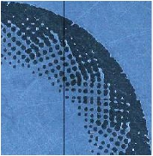

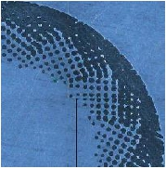
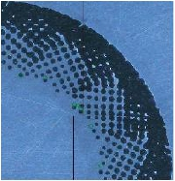
A. Design - 6/6 Produced Plate-2 A. Design - 6/6 Produced Plate-3

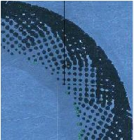

A. Design - 6/6 Produced Plate-4 A. Design - 6/6 Produced Plate-5

